Write a program for A* search algorithm using python code

Aim :To implement the A* search algorithm using Python.
Procedure:
Define the graph with edge costs.
Define the heuristic values for each node.
Start from the source node.
Select the node with the lowest f(n) = g(n) + h(n).
Continue until the goal node is reached.
Display the shortest path.

PYTHON CODE:
import heapq
graph = {
'A': [('B', 1), ('C', 3)],
'B': [('D', 3), ('E', 6)],
'C': [('F', 2)],
'D': [('G', 3)],
'E': [('G', 2)],
'F': [('G', 1)],
'G': []
}
heuristic = {
'A': 6,
'B': 4,
'C': 3,
'D': 2,
'E': 1,
'F': 1,
'G': 0
}
def astar(start, goal):
pq = [(heuristic[start], 0, start, [start])]
visited = set()
while pq:
f, g, node, path = heapq.heappop(pq)
if node == goal:
return path, g
if node in visited:
continue
visited.add(node)
for neighbour, cost in graph[node]:
if neighbour not in visited:
new_g = g + cost
new_f = new_g + heuristic[neighbour]
heapq.heappush(pq, (new_f, new_g, neighbour, path + [neighbour]))
path, cost = astar('A', 'G')
print("Shortest Path:")
print(" -> ".join(path))
print("Total Cost =", cost)

FLOWCHART:
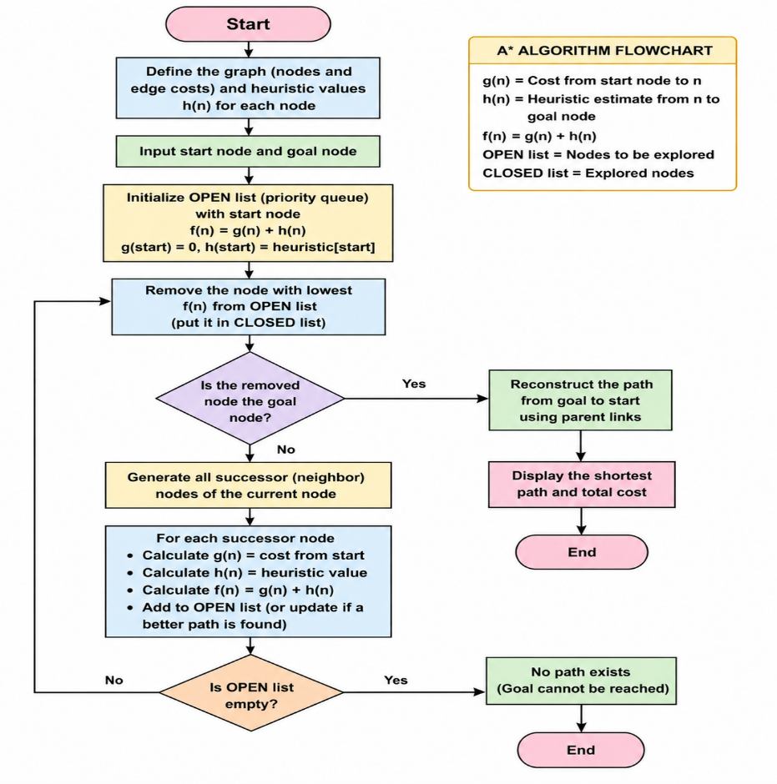

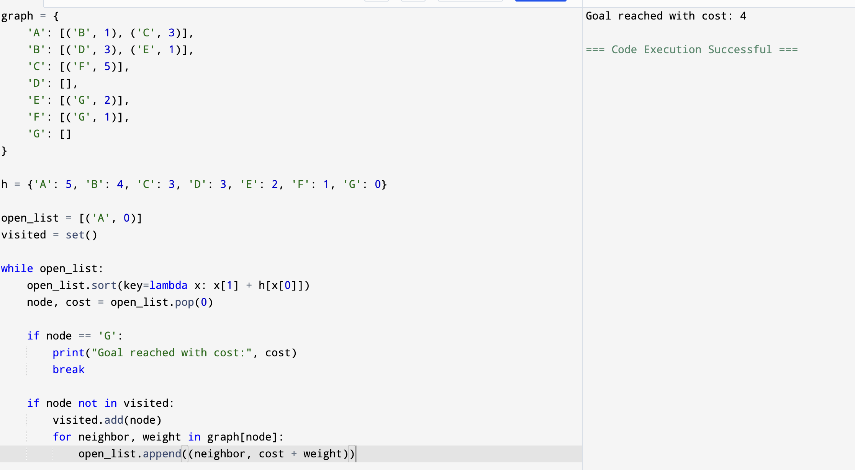
Output:

Result: Hence, A* (A-Star) search algorithm has solved

